Business to Business Personal Selling
Web Activity

Directions: Use the internet and ED puzzle Assignment on Google Classroom to complete this packet and answer the following questions:

Personal selling occurs and is directed toward the two types of customers, business to business and business to consumers. For this activity we will focus on business to business personal selling. Business to business personal selling is one business attempting to get another business to stock and sell their products to the consumer. Use the internet and answer the following questions:

- In your own words, define personal selling:

- Use the internet to find and list at least three advantages of personal selling.

- Use the internet to find and list at least three disadvantages of personal selling.

Directions: On google classroom is an Edpuzzle video. Watch the video to answer the following questions (along with the questions in the video). Be sure to pause and rewatch the video where needed to effectively answer these questions.

- From the video, why do you think personal selling is the best option for the farmer to sell his flowers? Give three reasons from the video.

- What are the three reasons a business will use personal selling to sell their products.

- How would you define the Sales Process/Cycle?

Sevan Steps to Selling:

Step 1: Lead Generating: Also known as .

Define lead generation:

What are 3 ways the farmer can generate leads?

What is a referral?

Step 2: Qualifying leads
What is Lead Qualification?

Step 3: The Pre-approach

Definition: where a business learns about other businesses that will sell their products by doing homework about these businesses.

What are at least three things the farmer should learn before meeting with a business?

Step 4: Developing a presentation with Solutions
Describe what a salesperson can do to try to get the customer to purchase their products (five given need 3 answers?

Step 5 Handling Objections
Describe in your own words what it means to Handle Objections in personal selling?

Step 6 Closing the Sale:
List four techniques the farmer used to close the sale (6 given in the video)

Step 7 Follow-up
List some techniques used in the follow-up process. List at least 4 ways.
Teacher Initials Upon Completion
Chapter 12 Preparing for the Sale

Section 12.1
Name:

Class Id:

Class Hour:
What is Personal Selling?
Objectives:
- Define Personal Selling
- Explain the purpose and goals of personal selling
- Understand what motives consumers to purchase
- Understand Feature Benefit Selling and Selling Points
Customer Buying Motives and Decisions

Two Motives for Making Purchases:

1. | Definition:  Examples:
2. | Definition:  Examples:

Customer Decision Making

3 Types of Decision Making

1 | Definition:  Examples:
2 | Definition:  Examples:
3 | Definition:  Examples:

Personal Selling:

Personal Selling:

4 Methods of Personal Selling:

1. | Definition:
2. | Definition:  Two Methods of B2B selling:  a.  b.
3. | Definition
4. | Definition

Goals of Selling

- Purpose and goals of selling

Feature Benefit Selling:

Features

Benefits

Selling Points

Feature Benefit Chart: One chart per product can help sales people sell products by identifying features and converting them to benefits:

Example: Product: Cough Medicine

Feature | Benefit
Cough, cold, and flu symptoms
#1 Pharmacist Recommended
2 times per day, 500 mg
New size: 80 for the price of 60
Fast Acting
2 Year Expiration date
Extra Strength Liquid Center
Money Back Guarantee

Product Features May be:

1 | Definition:
2 | Definition:
3. | Definition

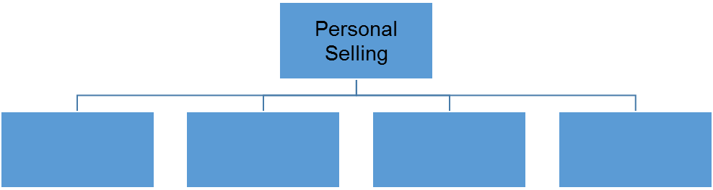
Study Organizer: What are the types of personal Selling and what are the goals of selling:

Goals:

Section 12.2 Getting Ready to Sell
Objectives:
- Name sources of product information
- Explain the main focus of preparation in business to business selling and in retail selling

The Pre-Approach:

The effectiveness of Face to face communication is:

About your body language Tone of Voice an Content

Preparing to assist customers, salesperson must:

1 | Four Sources:  1  2  3  4
2
3 | Prospecting:  Prospect:  Methods of Prospecting:
  A.
  B.
  C.
  D.
  E. | Two types:  1  2
  F.
4

Sales People are compensated by:

  - Sales Quotas

Preparing for the Sale in Business-to-Business Selling
- Pre-approach Activities

  - For Previous Customers:

  - For new customers:

Preparing for the Sale in Retail Selling
- Focus on what?

  - Responsibilities include:

